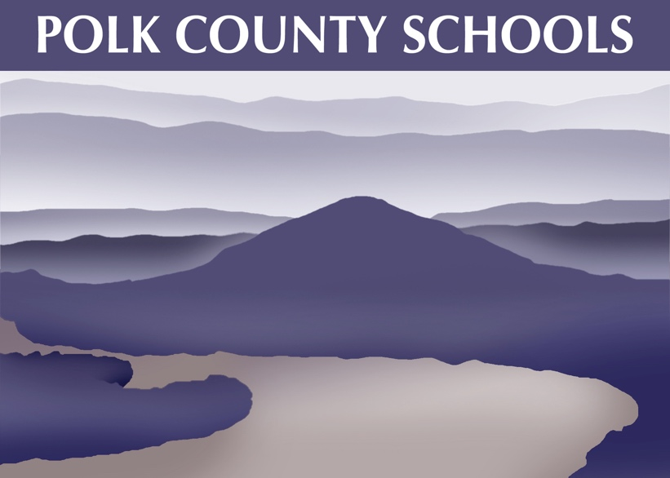

VISION
All students deserve our best effort to prepare them for the future.

MISSION
To provide our students the quality education needed to succeed in a challenging world.

Polk County Schools Five Year Strategic Plan
Goals
- Polk County Schools will educate and care for the whole child (students).
- Polk County Schools will seek to provide the best academics for ALL students.
- Polk County Schools will strive to hire and retain the best educators for our students.
- Polk County Schools will seek to be responsible in spending the funding provided by our citizens through our local, state, and federal governments.
- Polk County Schools will begin a building program for current and future students.
- Polk County Schools will put the utmost importance on the everyday safety of our students and employees.
- Polk County Schools will continue to improve community relationships.

Goal #1
- Polk County Schools will educate and care for the whole child (students).

Objectives
  - Implement programs to create a positive school culture and climate
  - Create an environment conducive to learning and provide for the care, welfare, and safety of all students
  - Continue to build Social Emotional Learning (SEL) into classrooms everyday
  - Reduce chronic absenteeism/Promote everyday attendance
  - Provide specialty services to ALL students to meet their needs, especially Special Education, Economically Disadvantaged, English Learners, Homeless, Migrant, Immigrant, etc.

Goal #2
- Polk County Schools will seek to provide the best academics for ALL students.

Objectives
  - Meet the instructional needs of every classroom
  - Emphasize Early Post-Secondary Opportunities
  - Strengthen Career and Technical Education
  - Meet or exceed testing expectations for all students in every area
  - Continue to support struggling students through RTI2, RTI-B (Behavioral)
  - Increase technology until the district is a one-to-one district
  - Increase the opportunities to produce essential workers through CTE programs
  - Provide high quality instructional materials for every student (books, online books etc.)

Goal #3
- Polk County Schools will strive to hire and retain the best educators for our students.

Objectives
  - Provide high quality professional development for all staff
  - Grow our own leaders and administrators
  - Use the TEAM evaluation system to improve teacher and student learning and growth
  - Continue to train teachers to use one to one devices in class and in a remote system
  - Continue training CTE teachers to use mathematics and literacy in every class
  - Develop a network with colleges/universities to recruit the best possible candidates

Goal #4
- Polk County Schools will seek to be responsible in spending the funding provided by our citizens through our local, state, and federal governments.

Objectives
  - Work with the local funding body to secure funding for the building program
  - Work to sufficiently fund our local school programs
  - Provide competitive salaries
  - Address technology needs
  - Provide proper supplies/textbooks/online resources
  - Provide safety upgrades
  - Work to secure more funding through grants and outside agencies
  - Evaluate the return on investment of every program/equipment purchased/leased

Goal #5
- Polk County Schools will begin a building program for current and future students.

Objectives
  - To replace the Benton Elementary School and Chilhowee Middle School buildings.
  - To upgrade existing buildings for safety and efficiency purposes

Goal #6
- Polk County Schools will put the utmost importance on the everyday safety of our students and employees.

Objectives
  - Upgrade and install new equipment at every campus
  - Continue partnership with the local Sheriff’s Office to provide certified officers as SROs.
  - Train all employees in safety protocols
  - Plan for future closures or hybrid teaching and learning due to health or safety emergencies
  - Review and update safety plans at each school annually
  - Make safety plans uniform (as much as possible) between buildings (language common to each building)
  - Provide transportation training for bus drivers, monitors, faculty, and students

Goal #7
- Polk County Schools will continue to improve community relationships.

Objectives
  - Continue to encourage parental engagement in all schools
  - Continue building relations with community partners in support of our schools
  - Encourage effective communication between schools, parents, and other stakeholders within the District
  - Provide a family-friendly atmosphere at all schools where parents can feel comfortable
  - Use School Connect for announcements from the schools or district to parents/guardians
  - Use school/district websites, Facebook, Twitter and other social media sites to post announcements

