Copper Basin High School

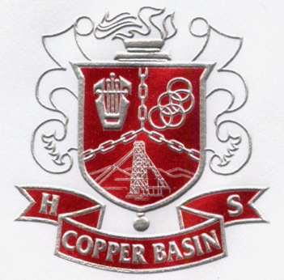

2025-2026
Student Handbook

Mrs. Holly Smith, Principal
Copper Basin High School
300 Cougar Drive
Copperhill, Tennessee 37317
Phone 423-496-3291
FAX 423-496-5308
Grades 7 through 12
Home of the Cougars and Lady Cougars
SACS Accredited
Member of TSSAA

Faculty

Barry Abbott, Special Education/Mathematics/Middle School Science
Dennis Baker, Music/Band/Color Guard
Angie Barker, High School Special Education/Mathematics
Bailey Beaver, Middle School Physical Education
Dr. Jared Bigham, Math 7/Computer Science
Ellen Carr, English 8
Karen Cribbs, Guidance Counselor
Amber Daly, Algebra I
Chris Dockery, Health /Medical CTE
Alex English, Business Technology CTE
James English, Construction CTE
Michael Fleeman, Geometry/Bridge Math
Shannon Fleeman, English Language Arts 7th grade/Creative Writing
Jeffrey Grimes, Physical Ed./Wellness/Boys’/Girls’ Basketball/Athletic Director
Brett Graves, Media/Head Football Coach
Barry Jack, Automotive Technology CTE
Angie Larson, Middle School Special Education
Shannon Marrie, English 11 & 12/Drama
Russell Matthews, Middle School Social Studies/US Government
Ginger Montgomery, Biology & Forensics/Color Guard
Tina Murphy, Instructional Technology Coach
___________, Math 8
_________, Physical Science/Chemistry
Holly Smith, Principal, Media Specialist
Kevin Smith, Work Based Learning Coordinator/Assistant Athletic Director
Steve Tompkins, Audio/Visual/Mechatronics CTE
Amy Underwood, World History/Personal Finance/Elective History
Emma Wood, Algebra II/ SAILS
Zulma Youngs, JAG Coordinator/Spanish/ Art History
Welcome
On behalf of the students, faculty, and staff, we welcome you to Copper Basin High School. We hope your high school career will be enjoyable and meaningful because we want these to be among the most important years in your life. The experiences you will have should promote understanding and intellectual development. We expect you to work hard and to conduct yourselves as ladies and gentlemen while you are students at Copper Basin High School.

To The Students
This handbook was developed by parents, students, faculty, staff, and administrators to better acquaint students at Copper Basin High School with school activities and to give information concerning matters that will be of interest to students. You must read this book thoroughly, be familiar with its contents, and sign the form on the back.

To The Parents
Parents of students attending Copper Basin High School are required to read this handbook. In it you will find useful information about your child's school. This information will be a great aid in advising your child and thus help to make his/her school life a happy and useful one. Your comments and suggestions are welcome. Phone 496-3291 or write 300 Cougar Drive, Copperhill, TN 37317. The form on the back page is to be read by the parent and the student and signed by both parties and returned to the school office.

Vision Statement
Copper Basin High School will foster a school culture that connects students with this community and their futures through high academic expectations, positive, caring relationships; and meaningful student engagement.

Graduates will demonstrate creativity, critical thinking, and a passion for learning necessary for personal success and satisfaction in an ever-changing global society.

Equal Opportunity Policy
Copper Basin High School does not discriminate on the basis of race, sex, color, religion, national origin, or disability.

Access to Student Records and Directory Information
The Family Education Rights and Privacy Act (FERPA) affords parents and students over 18 years of age (“eligible students”) certain rights with respect to the student’s education records. Additional information may be obtained from the principal or school counselor. Directory information is addressed under FERPA. Directory information includes, but is not limited to, the student’s name, address, telephone listing, date and place of birth, major field of study, participation in officially recognized activities and sports, weight and height of members of athletic teams, dates of attendance, degrees and awards received, and the most recent previous educational agency or institution attended. This information will be disclosed to appropriate agencies or media unless parents make a written request to the contrary.

Polk County Department of Education
131 Stephens Street
Benton, TN 37307
Phone 423-299-0471
FAX 423-338-2691

Dr. James Jones, Director of Schools
Dr. Jason Bell, Supervisor of Secondary Curriculum, TEAM
Dr. Ryan Goodman, CTE Supervisor, Human Resources, Verizon Grant
Mrs. Valerie Davis, Supervisor of Elementary Curriculum, Federal Projects
Mr. Tommy Frazier, Energy/Maintenance Coordinator
Mrs. Frances Bramblett, Special Education Supervisor
Mr. Sidney Jory, Transportation Supervisor

Polk County Board of Education
David Goode Jill Crago
Tim Worthy Nick Ratcliff
Angie Crowder Alex Pell
Marlene Miller Zach Miller
Dustin Cain. Hannah Price

Discrimination, Harassment, Bullying
Procedures for reporting harassment (which includes bullying and sexual harassment) are posted in each school. Students must report any events as outlined by the procedures.

Polk County School Board Policy 6.304
Students shall be provided with a learning environment free from sexual, racial, ethnic and religious discrimination/harassment (TCA 49-6-3109). It shall be a violation of this policy for any employee or any student to discriminate against or harass a student through disparaging conduct or communication that is sexual, racial, ethnic or religious in nature. The following guidelines are set forth to protect students from discrimination/harassment.
Student discrimination/harassment will not be tolerated (Title VII; 29 CFR 1604.11). Discrimination/harassment is defined as conduct, advances, gestures or words either written or spoken or a sexual, racial, ethnic or religious nature which:
- Unreasonably interfere with the student’s work or educational opportunities; or
- Create an intimidating, hostile or offensive learning environment; or
- Imply that submission to such conduct is made an explicit or implicit term or receiving grades or credit; or
- Imply that submission to or rejection of such conduct will be used as a basis for determining the student’s grades and/or participation in a student activity.
Alleged victims of sexual, racial, ethnic and religious discrimination/harassment shall report these incidents immediately to a teacher, counselor or building administrator (Title IX 20 U.S.C. 1681-1686). Allegations of discrimination/harassment shall be fully investigated by a complaint manager (as set forth in Student Concerns, Complaints and Grievances 6.305).
The privacy and anonymity of all parties and witnesses to complaints will be respected. However, because an individual’s need for confidentiality must be balanced with obligations to cooperate with police investigations or legal proceedings, to provide due process to the accused, to conduct a thorough investigation or to take necessary action to resolve a complaint, the identity of parties and witnesses may be disclosed in appropriate circumstances to individuals with a need to know.
A substantiated charge against an employee shall result in disciplinary action up to and including termination. A substantiated charge against a student may result in corrective or disciplinary action up to and including suspension.
There will be no retaliation against any person who reports harassment or participates in an investigation. However, any employee who refuses to cooperate or gives false information during the course of any investigation may be subject to disciplinary action. The willful filing of a false report will itself be considered harassment and will be treated as such.
An employee disciplined for violation of this policy may appeal against the decision by contacting the Federal Rights Coordinator or the Director of Instruction. Any student disciplined for violation of this policy may appeal the decision in accordance with disciplinary policies and procedures.
This policy shall be published in the parent/student handbook distributed annually to every student. Building administrators are responsible for educating and training their respective staff and students as to the definition and recognition of discrimination/harassment.

Section 504 of the Rehabilitation Act of 1973
District Coordinator – Frances Bramblett

School Coordinators – Mrs. Holly Smith
Mrs. Amber Daly

Teen Advocacy Phone Numbers Approved by Polk County Board of Education

Alcohol, Tobacco & Other Drugs
- TN Tobacco Quit Line 1-800-QUIT-NOW
- TN Bureau of Investigation 1-877-TNN-METH
- Meth Task Force 1-866-RID-METH
- National Institute on Drug Abuse 1-800-662-4357
- TN Red Line 1-800-889-9789
- Alateen Hotline 1-800-344-2666

Suicide Prevention
- National Suicide Prevention 1-800-273-TALK
- Mobile Crisis Team Hotline 1-800-704-2651

Abuse
- Families in Crisis, Inc. 1-800-675-0766
- Dept of Children’s Child Abuse 1-877-237-0004
- National Sexual Assault Hotline 1-800-656-HOPE
- Battered Women Hotline 1-800-334-2836
- Stop-It-Now 1-888-PREVENT

Teen Pregnancy
- Baby Line 1-800-428-2229
- Planned Parenthood 1-800-230-PLAN

Sexual Transmitted Diseases (STD’s)
- Covenant House Runaway Shelter 1-800-999-9999
- Teen Help 1-800-840-5704
- Contact Life 1-800-454-8336
- TN Voices for Children 1-800-670-9882

TN HELP CARD 1-800-835-0444
Searches
Any school official who has probable cause has the right to search the locker, clothes, books, car or other personal property on school grounds. Observe this and do not bring any substance to school that violates school rules. State law gives school officials the right to search school storage areas.

Schedule
High School - The school year is divided into two Blocks--fall and spring. A Block consists of 18 weeks (about 4 months) with a mid-term and final exam. A progress report will be sent to parents every 3 weeks and report cards will be sent to parents twice each Block.

Middle School – The school year is divided into two Semesters--fall and spring. A Semester consists of 18 weeks (about 4 months) with two 9 weeks (about 2 months) tests. Within each 9 weeks (about 2 months), a 3-week progress report will be sent to parents.

Bell Schedule (first bell will ring at 7:55, classes begin at 8:00)

Middle School High School
1st Period 8:00 – 9:20 1st Period 8:00 – 9:20
2nd Period 9:25 – 10:45 2nd Period 9:25 – 10:45
Lunch 10:50 – 11:20 RTI 10:50– 11:20
RTI 11:25 – 12:10 Lunch 11:25-12:10
3rd ^{Period} 12:15 – 1:35 3rd Period 12:15-1:35
4th Period 1:40-3:00 4th Period 1:40 – 3:00

Bus riders will be called for dismissal at the end of the day 3:00 p.m. Students who are car riders will be called for dismissal after the buses leave the parking lot. No car riders will be permitted to walk to the parking lot to leave. They must be picked up in the pick-up line. Car drivers and their riders will be dismissed after car riders have left the parking lot. Student drivers are to leave the parking lot immediately. ANY BUS ON THE CAMPUS HAS THE RIGHT-OF-WAY.

School Closing
In the event of severely inclement weather or mechanical breakdown, school may be closed, or the starting time may be delayed. The same conditions may also necessitate early dismissal. School closing delayed starting time, or early dismissal will be announced through the school systems School Reach calling system, social media, and over local radio stations WLSB (1400 am) and WPPL (103.9 FM), and on TV station Channel 3, Chattanooga.

If no report is heard in the morning by 7:00 a.m., it can be assumed that school will be in session on a regular schedule. Please DO NOT CALL THE SCHOOL regarding closings, etc. School phone lines must be kept open for emergency communication.
FAILURE TO RETURN THE FORM ON THE BACK SIGNED BY GUARDIAN AND STUDENT WILL NOT RELIEVE A STUDENT OR GUARDIAN FROM RESPONSIBILITY OF COMPLYING WITH RULES CONTAINED WITHIN THIS HANDBOOK OF POLICIES AND PROCEDURES.

Rules and Regulations
Students are acquainted with the school’s rules and regulations at the beginning of each school year. The principal and/or assistant principal meet with each class, review the current rules, and have students and parents sign a statement that they are aware of the policies.

Note: This book is not intended to detail or answer all questions concerning Copper Basin High School and its activities. It is to serve only as a guide. Administration reserves the right to make final decisions.

These policies and procedures are on file in the superintendent's office. Any student or parent can check out these policies or obtain a copy of them upon request to the superintendent's office.

Traffic in Halls
Please keep to the right. Do not run in the halls. Students are not to linger in halls, around lockers, drinking fountains, block the doors or halls, or sit in the halls. Please put wastepaper in containers provided. Keep paper off hall and room floors, and grounds. If a student is not in his seat when the bell begins to ring, it will be an unexcused tardy. Students are to walk keeping their hands to themself without having arms around each other. A hall pass is required for any students in the hallways after the bell has sounded.

Driver’s License or Permit
Students under eighteen years old who wish to apply for a Tennessee driver’s license or learner’s permit must show proof of satisfactory school attendance and academic performance. Students must pass at least two academic subjects in the most recent term and have less than ten consecutive or fifteen unexcused absences. The required certificate may be obtained in the school office. Violations are reported to the Tennessee Department of Safety and will result in license denial or revocation.

Cars at School
Those students who drive to school are to register their cars and license number in the principal's office on a form provided by the office. A five-dollar registration ($5.00) fee is required per semester on all cars registered.
- Park in designated areas. Do not block other cars.
- Do not leave school grounds during school hours without permission.
- You are not to sit in parked cars or return to your car until it is time to leave school.
- Observe all laws (Speed Limit is 10 M.P.H.)
- You must be properly licensed and insured to drive to school.
Cars parked on school grounds are subject to search.
Failure to comply with these rules will result in loss of driving privilege.
Illegally parked cars may be towed at the driver's expense and may receive a cash fine to be paid before he/she drives again.

Lockers
- Assignments of lockers will be made from the Media Center. There is a $5.00 locker fee. If a lock is placed on the locker a code or extra key must be given to the Administration.
- Slamming locker doors not only makes needless noise but may damage doors. Please be quiet when closing them.
- Students are expected to always keep the interior of lockers clean and neat. The outside of the locker door is to be clear of signage unless placed by administration
- The storing of valuables in a locker is not advised. The school is not responsible for lost or stolen articles.
- Students are expected to use their assigned locker. Sharing is not allowed without the permission of the principal.
- Because of the increasing concern about school violence and school safety backpacks must be placed in lockers as soon as they arrive at school.

Discipline
In general
You should always behave as a lady or gentleman. It is important that your conduct be such that it always reflects well on your school, your family, and yourself. When you apply for admission to college or for a job, the school or employer will contact us, not only for grades, but also for an evaluation of your honesty, dependability, cooperativeness, courtesy, influence and other character traits. Don't take a chance with your future.
This handbook speaks generally to many items of student discipline. The Polk County Board of Education has adopted a specific code of Student Discipline and Behavior that is available in the library and principal's office. Each student is responsible for knowing and following its contents. Please familiarize yourself with the code.
In compliance with state statute T.C.A. 49-6-4216, the Polk County School Board provides written notification to students and parents that policies and procedures in the following areas have been developed and adopted by the School Board and are now in effect in the Polk County School System:

Misbehavior & Discipline Level I
Minor misbehavior on the part of the student which interferes with the orderly operation of the school may be punished by the following: (1) verbal reprimand, (2) special assignment, (3) restricting activities, (4) behavior modification, (5) assigning work details, (6) counseling, (7) withdrawal of privileges, (8) strict supervised study, (9) detention, (10) corporal punishment.
Examples of Level I misbehavior include (but are not limited to) the following: (1) classroom disturbances, (2) classroom tardiness, (3) cheating and lying, (4) abusive language, (5) non-defiant failure to do work or carry our directions, (6) student driving violations, (7) library deficiency, (8) failure to comply with homeroom requirements, and (9) missing or late for detention.

Misbehavior & Discipline Level II
Misbehavior whose frequency or severity tends to disrupt the learning climate of the school may be punished as above and also by the following: (1) modified day, (2) social probation, (3) peer counseling, (4) referral to outside agency, (5) Saturday school, (6) suspension from school sponsored activities or from riding the school bus, (7) restricting the honors a student is otherwise due, (8) alternative school.
Examples of Level II misbehavior include (but not limited to) the following: (1) continuation of Level I misbehaviors, (2) school tardiness, (3) truancy, (4) using forged notes or excuses, (5) disruptive classroom behavior, (6) cutting class, (7) violation of the dress code, and (8) Public Display of Affection (PDA).

Misbehavior & Discipline Level III
These are acts directly against persons and property that do not seriously endanger the health and safety of others. They are punishable by: (1) Saturday school, (2) detention, (3) corporal punishment, (4) restitution for loss, damage, or stolen property, (5) out-of-school suspension (exceeding 10 days), and (6) suspension from school activities.
Examples of Level III misbehaviors include (but not limited to): (1) continuation of Level II misbehaviors (2) simple fighting, (3) minor vandalism, (4) stealing, (5) threats to others, (6) leaving school without permission, and (7) immoral acts.

Misbehavior & Discipline Level IV
Acts which result in violence to another person or property or which pose a threat to the health and/or safety of others in the school are punishable by: (1) out-of-school suspension for more than 10 days, (2) suspension from school activities, (3) expulsion, (4) other Board action which results in appropriate placement.
Examples of Level IV misbehaviors include (but not limited to): (1) continuation of Level I, II, and III misbehaviors, (2) extortion, (3) bomb threat, (4) possession / use/transfer of dangerous weapons, (5) assault / battery, (6) vandalism, (7) theft / possession / sale of stolen property, (8) arson, and (9) furnishing / selling / possession / use of unauthorized substances.

Juvenile Citations
Offenses which constitute juvenile citations include but are not limited to (1) possession or use of tobacco products, (2) assault, or the threat of assault, (3) disorderly conduct, and (4) truancy, (5) any class time missed due to OSS (out of school suspension).

In School Suspension (ISS)
ISS was designed to take care of minor discipline and administrative problems and to serve as a mechanism for behavior modification. Students will be given at least 1-day notice of detention unless the discipline calls for immediate action. ISS is used to isolate students from their peers while serving this discipline. If a student athlete is placed in ISS, they will not be eligible to play in sporting games on the day of ISS.

Detention After School
Detention was designed to take care of minor discipline and administrative problems and to serve as a mechanism for behavior modification. Students will be given at least 1-day notice as to when to report. Detention will be after school from 3:00 p.m. until 4:00 p.m. Students must bring work to detention. Students who do not report to detention on the assigned day will have a day added each time they miss and will not be able to attend any school functions until the detention days are done. After the third (3) time the student will be suspended or placed in Saturday school. Any student who receives more than 3 separate detentions in a 9-week period will be suspended, placed in alternative school, or in Saturday school.

Dress Code
All students are expected to adhere to the dress code at all times and all places at Copper Basin High School. Students shall dress and groom in a clean, neat and modest manner so as not to distract or interfere with the operation of the school. When a student is attired in a manner that is likely to cause disruption or interference with the operation of the school, the principal shall administer appropriate punishment, which may include suspension and/or expulsion. Faculty, parents, students, and the principal developed the following guidelines. Students at Copper Basin High School are expected to follow these guidelines.
  - No hats are allowed at school. Students may not bring hats or caps or other head coverings to school. These items will be taken up and not returned if the students have them at school.
  - All shirts and tops must have sleeves covering shoulders, and a modest neckline, must be long enough to tuck in, and must not be see-through. All pants are to be worn fitting at the waist. Very wide-legged pants are not permitted.
  - No drawing on your body with ink, markers, paint, or any related materials is allowed.
  - No article of clothing may be worn which implies or otherwise mentions alcohol, sex, tobacco, drugs, or offensive language.
  - The American flag will not be worn on clothing in an unpatriotic manner.
  - No bandanas are allowed at CBHS
  - Shorts or pants may be worn year-round providing that students stay within reasonable guidelines, which are as follows:
    - No cut-off of any length
    - No holes or tears in shorts or pants
    - No shorter than 3” above the knee.
    - Must be worn fitting at the waist and no excessively wide pant legs are allowed.
  - Dresses and skirts must be no shorter than 3” above the knee. Dresses must conform to the same standards as listed above for shirts and tops. Dresses must have sleeves and have a modest neckline.
  - Shoes will be worn at all times.
  - This policy is in effect for all school activities both on and off campus. The only exception is formal dress at the prom. Clothing for this occasion is also expected to be in good taste and modesty.
  - If athletes practice in uniforms not conforming to the dress code, they must change clothes before entering the building except in the event of an emergency.
  - Piercing jewelry may be worn only in the ear. A stud is permitted to be worn in the nose. Protruding metal studs are not permitted on clothing or jewelry. Body piercings and chains are prohibited. Earring gauges are not permitted. Any unlawful piercings will be confiscated and returned at the end of the year.
  - No excessively large chains are allowed
  - Painting, spraying, or marking of the face, hair, or other exposed body parts is not permitted. Hair is not to be sprayed or dyed in unnatural colors (such as blue, pink, green, orange, yellow, etc). All hair colors must be natural color tones with styles that do not distract from the learning process. All students are to wear their hair so that it does not cover the eyes.
  - Writing on body and clothes is not permitted.

  - No pajamas or house shoes are permitted.
  - Any dress considered to be a disruption to the school environment will be prohibited.
  - All students at Copper Basin High School are expected to follow this policy.

Leaving School Grounds
A student who plans to leave school during the day for any reason must bring an authorized note from home with their parents’ signature and a phone number where they can be reached at the office before 1st period for early dismissal. The student must also have a parent call the school verifying the authorized note. If a student is excused from the principal's office to leave school during school hours, he or she is to sign out in the office, giving destination and time of departure; upon returning, the student must sign in giving the time of return of the same day. Students will be given permission to leave ONLY with parental permission. In case of an emergency that would require a student to leave during the day, the student may leave if proper permission from a parent or guardian can be given by phone. The school will grant the parent's request for early dismissal. Students are not allowed in the parking lot during school hours unless permission from the principal or designer. Students may not sign-out for lunch and return to school.

Prescription and Nonprescription Forms
All prescription and nonprescription medication must be delivered to the office by a parent or guardian in the original bottle or container. The parent or guardian must complete the appropriate paperwork before medication is left at the school or taken by the student. No medication is allowed to be carried throughout the school by a student unless prior approval and authorization has been made and the correct forms are on file.
Failure to properly check-in ANY medication will result in discipline actions taken.

Zero Tolerance
To ensure safe and secure learning environments free of drugs, drug paraphernalia, violence and dangerous weapons, including any knife or instrument with a blade of any type; and to impose swift, certain and severe disciplinary sanctions on any student:
Who brings a drug, drug paraphernalia or a dangerous weapon, including any knife or instrument with a blade of any type, onto a school bus, onto school property or to any school event or activity; or who, while on a school bus, on school property or while attending any school event or activity: Is under the influence of a drug: or Possesses a drug, drug paraphernalia or dangerous weapon, including any knife or instrument with a blade of any type, or Assaults or threatens to assault a teacher, student or other person.

The School Board also has a zero-tolerance policy toward any student who engages in such misconduct. Such misconduct will be promptly reported to appropriate law enforcement authorities and may also provide for deployment of law enforcement officers and/or school safety and security personnel and use of dogs trained to detect marijuana and other drugs.

Drug Testing
According to the Polk County Board of Education Policy, written notice is required to students about the Student and Alcohol and Drug Testing Policy. Descriptor Code 6.3071 in the Board Policy Manual gives the school principal authority to order drug tests for individual students when there is a reasonable cause to believe that:
- The school board policy on alcohol and drug use have been violated
- A search of lockers/belongings produce evidence of the presence of drugs and/or alcohol
- A search of persons and containers produced evidence of presence of drug and/or alcohol
- A search of vehicles produced evidence of the presence of drugs and/or alcohol
- Through observation or other reasonable information reported by a teacher, staff member, or other student that a student is using drugs and/or alcohol on school property.
If the need for testing arises, the parent/guardian(s) will be notified, and due process will be given to the student. The results of the test are confidential. If necessary, appropriate punishment, which could include a zero tolerance (365 days) suspension, will be ordered.

ATTENDANCE AND REGISTRATION

Attendance is a key factor in student achievement, and therefore, students are expected to be present each day school is in session. The Director of Schools/designee shall develop appropriate administrative procedures to implement this policy. The attendance supervisor shall oversee the entire attendance program which shall include:
- All accounting and reporting procedures and their dissemination.
- Alternative program options for students who severely fail to meet minimum attendance requirements;
- Ensuring that all school age children attend school;
- Providing documentation of enrollment status upon request for students applying for new or reinstatement of driver’s permit or license;
- Notifying the Department of Safety whenever a student with a driver’s permit or license withdraws from school.
Student attendance records shall be given the same level of confidentiality as other student records. Only authorized school officials with legitimate educational purposes may have access to student information without the consent of the student or parent/guardian.

Absences shall be classified as either excused or unexcused as determined by the principal/designee. Excused absences shall include:
- 3 parent notes per semester with proper documentation
- Professional appointments
- Death in the immediate family
- Religious observances
- College visits
- Department of Transportation appointments
- School sponsored or school endorsed activities
- Summons, subpoena, or court order
- Circumstances which in the judgement of the principal create emergencies over which the student has no control.
The principal shall be responsible for ensuring that:
- Attendance is checked and reported daily for each class;
- Daily absentee sheets contain sign in/sign out sheets and indicate students present or absent for the majority of the day;
- All student absences are verified;
- Written excuses are submitted for absences and tardiness;
- System-wide procedures for accounting and reporting are followed.

TRUANCY
Annually, the Director of Schools/designee will give written notice to the parents/guardians that attendance is required. Students shall be present at least fifty percent (50%) of the scheduled school day to be counted present. Students may attend part-time days, alternating days, or for a specific amount of time as indicated in their Individualized Education Plan or 504 Plan and shall be considered present for school attendance purposes. If a student is required to participate in a remedial instruction program outside of the regular school day where there is no cost to the parent/guardian and the school system provides transportation, unexcused absences from these programs shall be reported in the same manner.
A student who is absent three (3) days without an adequate excuse shall be reported to the Director of Schools/designee who will, in turn, provide written notice to the parent/guardian of the student’s absence. If a parent does not provide documentation within adequate time excusing those absences, or request an attendance hearing, then the Director of Schools shall implement the progressive truancy intervention plan described below prior to referral to juvenile court.

Progressive Truancy Intervention Plan
Prior to referral to juvenile court, the following progressive truancy intervention plan will be implemented.
Tier I
Tier I of the progressive truancy intervention plan shall include the following Attendance 6.200 Page 3 of 5
- A conference with the student and the student’s parent/guardian;
- An attendance contract, based on the conference, signed by the student, the parent/guardian, and an attendance supervisor or designee. The contract shall include;
- A specific description of the school’s attendance expectations for the student; b. the period of which the contract is effective; and c. Penalties for additional absences and alleged school offenses, including additional disciplinary action and potential referral to juvenile court; and regularly scheduled follow-up meetings to discuss the student’s progress.

Tier II
If a student accumulates additional unexcused absences in violation of the attendance contract in Tier I, the student will be subject to Tier II. Under this tier, a school employee shall conduct an individualized assessment detailing the reasons a student has been absent from school. The employee may refer the student to counseling, community-based services, or other services to address the student’s attendance problems.

Tier III
This tier shall be implemented if the truancy interventions under Tier II are unsuccessful. These interventions shall be determined by a team formed at each school. The interventions shall address student needs in an age-appropriate manner. Finalized plans shall be approved by the Director of Schools/designee.

It is the belief of the school system that students are best served educationally when they are in attendance every day possible. With that in mind, the school system has the following guidelines for attendance:
- Truancy is a citable offense in juvenile court and will not be tolerated.
- A student is considered truant when he / she has missed 4 days in a given class. This student will be issued a warning by the administration.
- Any student missing 7 days in a given semester will be issued a citation to juvenile court.
- If a student is considered truant, all attendance privileges, such as leaving early or checking in late, can be revoked.
- Students missing more than 20 minutes in a given class will be considered absent for that class.
- After a student has reached the total number of days, students may file a grievance that will be heard by the administration before the student is taken to court. Grievances should only be filed in extenuating circumstances and will be handled by administration on a case-by-case basis.
- A doctor’s excuse will be required to make up any semester or final exams.
- The Tennessee Department of Safety can take a student’s drivers license for having 10 consecutive unexcused absences or a total of 15 unexcused absences.
- Homebound is available upon receipt of a doctor’s completed homebound form and must follow the guidelines set forth by the Board of Education. Students will then continue their studies through a teacher in the home.

The laws of Tennessee recognize only the following as legitimate excuses for temporary absence from school: personal illness, illness of immediate family member, death in the family, religious observances regularly observed by persons of a certain faith, circumstances, which in the judgment of the principal, create emergencies over which the student has no control.

Late Arrivals
Students who are late arriving to school or class must report to the office for an admit to class and must sign in. Students missing twenty minutes (20) or more of a class will be counted absent from that class. Students arriving to class under 20 minutes will be considered tardy.

Checkout Procedures
Students may leave school only with their parents’ permission and must sign out in the office. It is preferable that parents come to the school if a student must leave before the end of the school day. If this is not possible, a note and a phone call are required. Students may not check out for lunch. Students will not be allowed to check out between the times of 11:00 and 1:00 unless a professional note can be provided. Time missed because of checking out is accumulated and may be considered truancy. The fifth unexcused checkout will result in a court citation.

Make-Up Work
Students who have been absent may make-up work within three (3) days of returning to school. Students returning to school after absences must check with their teachers on the day, they return regarding any work missed. Scheduling make-up work is totally the responsibility of the student and failure to fulfill this obligation will result in a loss of credit for the work missed. Students will have a maximum of 3 days to make up work. Makeup will be allowed in the current 3-week grading period only. If the absences come at the end of the grading period, the student will be given 3 days to make up the work.

Hall Passes
Students who are in the halls during class periods must have a pass from an authorized staff member. Failure to produce a hall pass during class-time will result in in-school suspension. The public telephones are not to be used during class times. Students are to use the telephone designated for student use. Students are not to use telephones in the office.

Telephone
No student will be called from class to answer calls unless the call is of an emergency nature. Please inform parents and others not to call the school to speak to you nor to give you messages unless there is an emergency.

Electronic Devices
Personal telephones, personal audio devices, handheld video games, smart watches, or any type of laser light pointers will be considered as Personal Communication/Electronic Devices. See the following policy: (note the devices are NOT allowed in the restrooms)

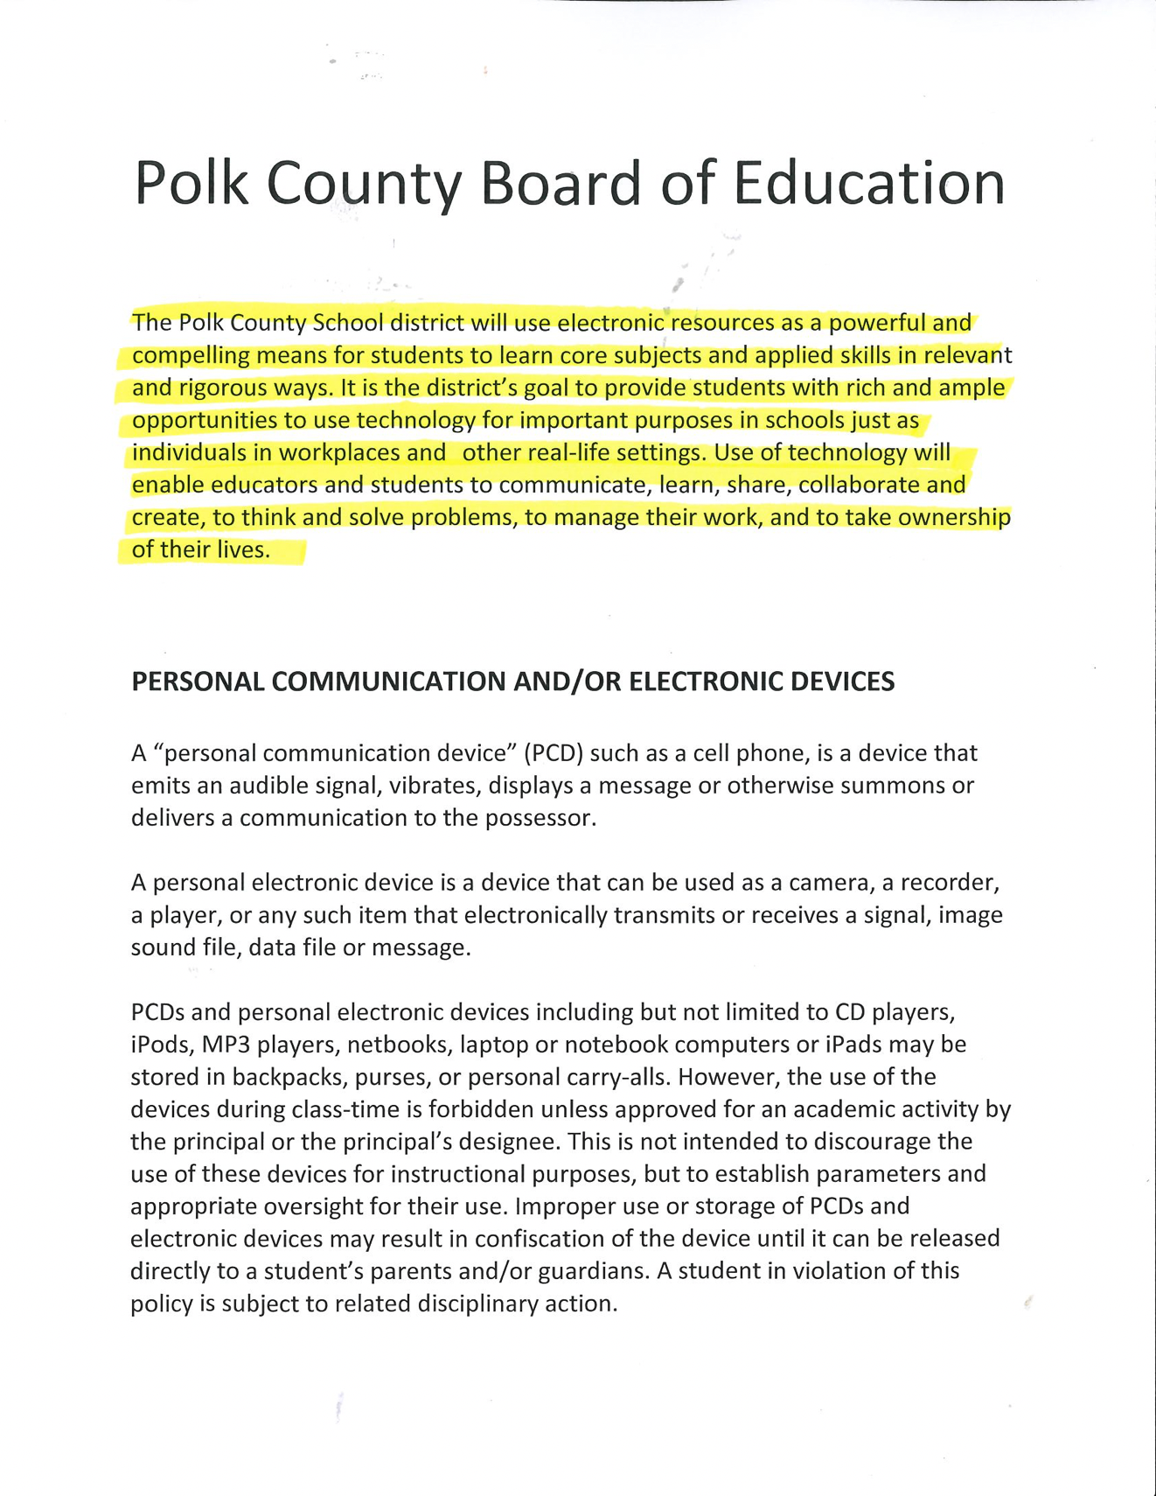
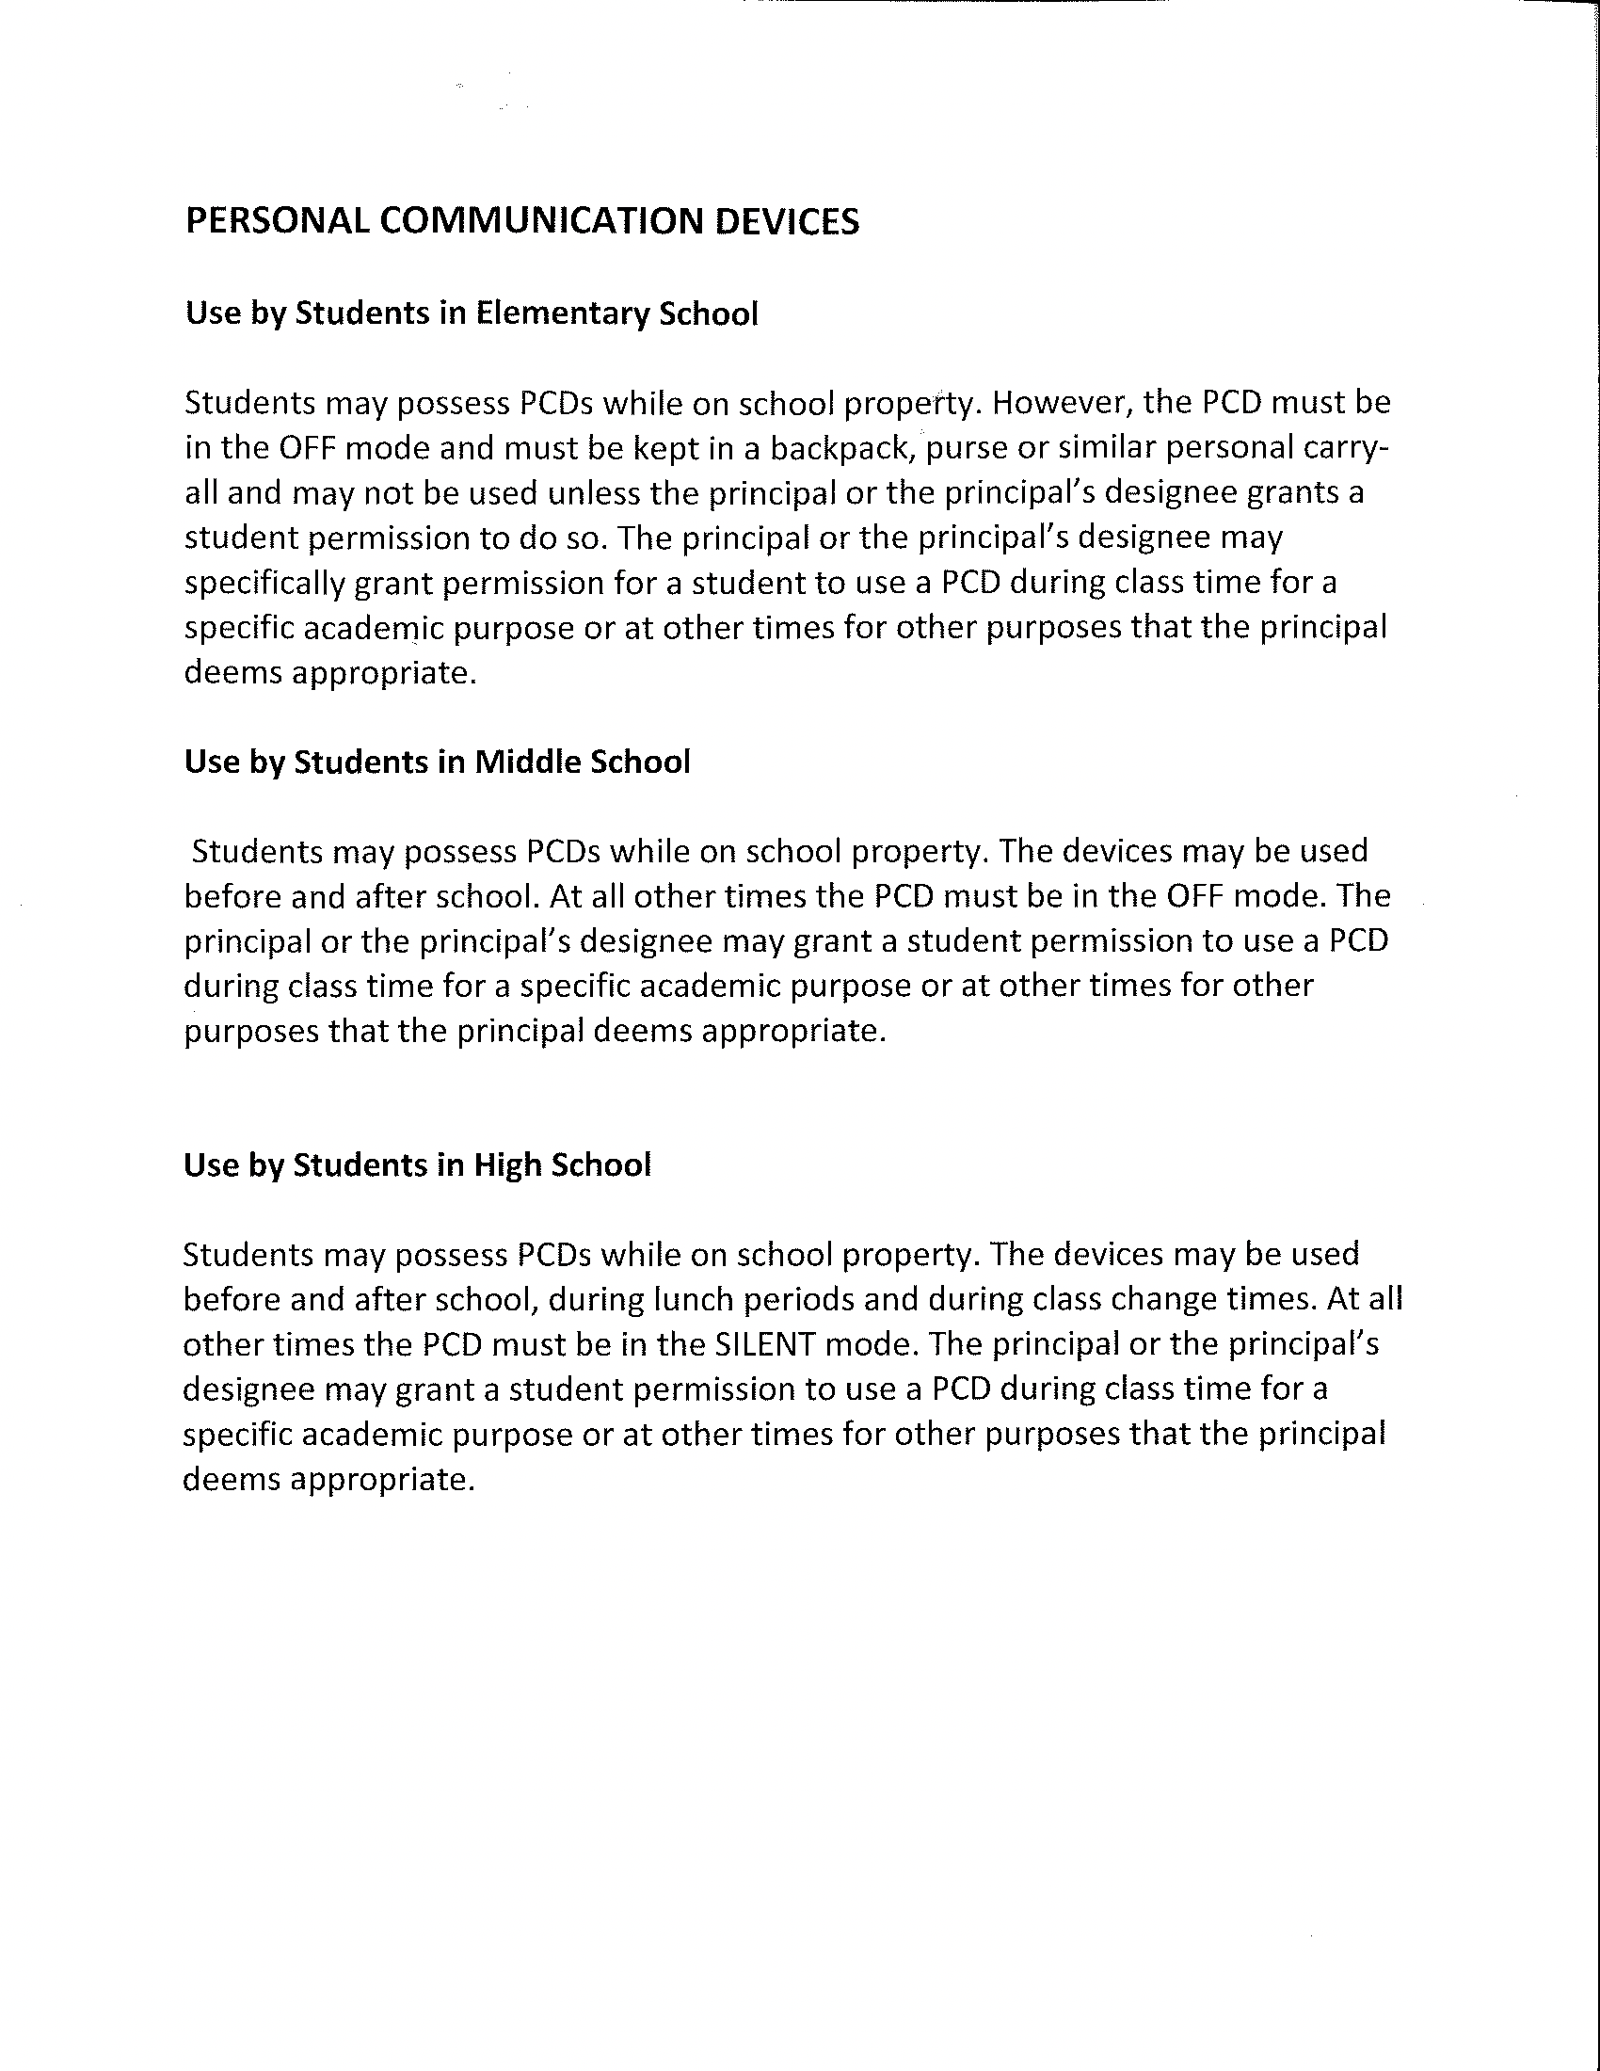
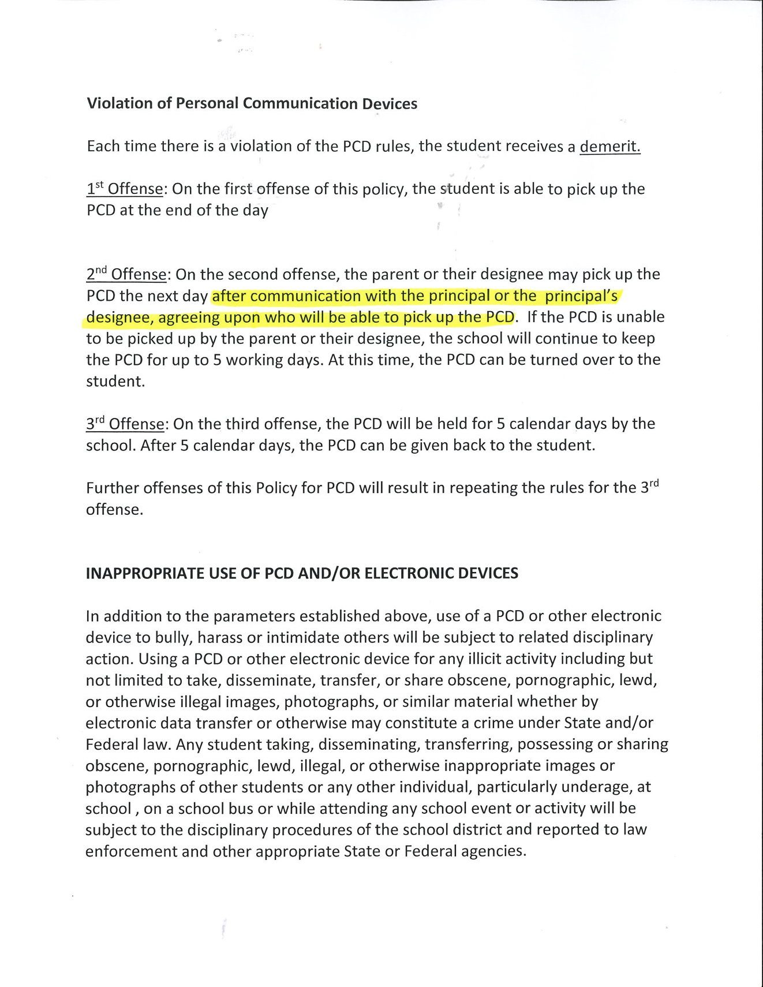

Visitors
To maintain the condition and atmosphere suitable for learning, no person shall enter onto the school grounds or into the buildings of public schools during the hours of student instruction except students and other persons with lawful and valid business on the school premises. Parents and all other visitors are always welcome at Copper Basin High School but must always report to the main office with their form of identification to sign in and obtain a visitor’s pass and sign out when leaving the campus. Anyone improperly on a school's school premises shall depart on the request of the school principal or other authorized person.
The principal or other authorized person has complete authority to exclude from the school premises any persons he has reason to believe are disrupting the educational programs in the classroom or in the school and/or are disturbing the teachers or children on the premises for the purpose of committing an illegal act. Law enforcement officials may be called if the situation warrants such a measure.
Students at other schools and children not of school age will not be issued passes unless accompanied by parents.

School Fees
Some courses have nominal fees for materials and/or equipment necessary for the meeting of course objectives. These fees have been approved by the Polk County Board of Education. Teachers of courses with a fee inform students of the amount at the beginning of the semester and set a reasonable deadline for fees to be paid.

Personal Checks
The office at Copper Basin High School will accept personal checks. If checks are to be used, they must be made out to the club or person in charge of a fund-raiser. If you need to pay for lunch with a check the check must be made out to Copper Basin High School Cafeteria and be approved by the cafeteria staff.

Tobacco Policy
Tennessee Code Annotated 39-17-1504 Youth Access to Tobacco Act
A law enforcement officer or school principal who has evidence of the violation shall issue any person who violates this section a citation. The citation shall require the person to appear in the Juvenile Court for the county in which the violation is alleged to have occurred. A violation of this section shall be a civil offense, the penalty for which is a civil penalty of not less than ten dollars ($10.00) nor more than fifty dollars ($50.00). Students will have to complete a Drug, Alcohol and Tobacco course set forth by the Juvenile Court. Upon its determination that the person has violated this section, the Juvenile Court shall determine the amount of the civil penalty. The Juvenile Court may also impose community service work not exceeding fifty (50) hours for a second or subsequent violation within a one (1) year period.

Students 18 years and older who use or possess tobacco products (this includes vapor and vapor paraphernalia, electronic cigarettes, electronic breath fresheners, any devices producing a vape, fume, aerosal, or smoke etc.) on school property or school functions will be suspended or otherwise disciplined by the principal.

Emergency Evacuation Procedures
Students are informed of fire and tornado drill procedures for each classroom at the beginning of each school year and throughout the year. An armed intruder alert drill will also be performed. Students are not to talk during these procedures.

Counseling Services
The counseling staff provides services to students in the areas of curriculum planning, college information, test interpretation, scholarship applications, career awareness, and problems with which students may need help. A counselor is available from 8:00 am to 3:00 pm.

Withdrawals
Students who transfer to other school systems must officially withdraw from Copper Basin High School on the last day of attendance. A parent/guardian must come to the school. The withdrawal form is obtained from the office and must be signed by each teacher, librarian, cafeteria manager, and parent to indicate that all accounts (books, fees, equipment, etc.) are clear. The form must then be brought back to the office for final processing. No records can be sent to the admitting school until a signed request is received.

Polk County Charge Policy
Polk County School District/LEA allows students to accumulate charges to 5 days. Ala carte items are not allowed to be charged. Written notices will be sent home twice a month with students requesting payment. A copy will also be sent to the office for the principal’s review. The cafeteria manager will make every effort to collect student charges. Parents may receive a citation to court for unpaid lunch charges.

Library
The Copper Basin High School Library offers students materials for research and recreational reading. The Internet is available as well as books, magazines, and newspapers. The library is a place for quiet study and reading. The hours are from 8:00 am to 3:00 pm. A fine of twenty-five cents (.25) per day for each book overdue will be charged to the last person checking out the book. Lost books shall be paid for by the student to whom the book has last been checked out. Detention can be assigned for library deficiencies. Seniors will not be allowed to participate in graduation if they have a library deficiency. Students who are not seniors will not receive their report card until deficiencies are paid.

Textbooks
All textbooks are furnished by the State of Tennessee and Polk County Board of Education. Students shall be expected to take care of these books and return them at the end of the course. Students and their parents shall be held responsible for books that are lost, stolen or otherwise unaccounted for. Students will be charged for books that are damaged or defaced, other than normal wear, according to the extent of the damage. Students are to use only those books issued by the teacher.

Athletics
Several sports are available for students who have the ability and drive to compete at varsity or junior varsity level. Participation in interscholastic athletics requires that students be enrolled full-time and pass at least three subjects in the school year preceding participation in the sport. Sports currently available are softball, basketball, volleyball, cheerleading, football, and baseball. Student athletes must comply with TSSAA rules and regulations. 7th Grade students are not allowed to participate in varsity level sports. 8th grade students can play on varsity if the coach obtains permission from the principal.

All athletes must have a physical exam required by TSSAA before participating in any extracurricular activity listed below. Any player/student that fails to return school uniforms or equipment is subject to a fee and placed on restrictions for additional or future sports or extracurricular activities.

Copper Basin High School has always been extremely proud of our tradition of fielding outstanding sports programs. Students interested in playing sports should make plans in the fall so that their schedules can be adjusted accordingly. School letters are awarded by the school to those who have earned them. CBHS follows TSSAA regulations relative to participation in athletics. The head coach is the final authority in the selection of the team members.

CBHS offers participation in the following sports:

Baseball: Spring sport for boys.

Basketball: Winter sport for boys and girls.

Football: Fall sport for boys.

Golf: Fall sport for boys and girls.

Softball: Spring sport for girls.

Volleyball: Fall sport for girls.

Cheerleading: Cheerleaders and alternates are selected each year. They direct cheering sections of all football and basketball games. Any student interested in becoming a cheerleader is eligible to try out, provided they have an acceptable attendance, conduct record and meets TSSAA regulations. They must meet the same eligibility rules as players and abide by additional rules as outlined by the sponsor.

Managers must meet the same eligibility requirements as players.

CBHS follows TSSAA regulations relative to participation in athletics.
To be eligible to participate in athletic contests during any semester, a student:
- Must have made a passing grade in three (3) courses the preceding semester.
- Shall be regularly enrolled and in regular attendance.
- Who drops out of school before the end of the term shall be ineligible to participate in secondary school athletics until he has been in school a term and has passed at least three full units.
- 7th Graders are not allowed to play varsity high school sports.
- 8th Graders are allowed to play JV high school sports not varsity.

OSB (Official School Business)
Official School Business is a privilege granted to students representing our school in an official capacity. Such absences should not adversely affect a student's grade in any way if the student makes a sincere effort to make up all the work.
- Official School Business is determined by the Administration. Faculty will abide by the decisions.
- Faculty sponsors will make every effort to notify teachers when students are to be absent for OSB.
- Students should realize that academics are their priority and should use discretion in choosing OSB activities.
- Each student must consult with each teacher BEFORE going on OSB.
- Students on OSB will have all make-up privileges.
- If a student is absent more than 1/2 day on the day before O.S.B., he/she will not be given O.S.B. and will remain in the regular classroom.
- Students wanting a 1-day O.S.B. must be passing all classes they are currently taking or have the teacher they are failing give special permission to receive the OSB.
- Students should not have more than 2 O.S.B. days in any 9-week grading period.

School Activities
All athletic events are under the school's supervision, and the TSSAA regulations hold the school responsible for conducting them. Students are subject to regular school policies at ALL games. Poor sportsmanship and bad conduct may result in a school being suspended from any athletic event.

At all school activities, the faculty member in charge shall have full authority and the rules of good conduct and cooperation should be observed. Misbehavior at activities or during the school day may result in suspension from extracurricular attendance for an extended period

Extracurricular Activities
Students who have an unexcused absence during the day may not participate in extracurricular activities that day or night. School rules and regulations apply to students participating in a school-sponsored activity off campus or after school.

Deficiencies
Students must pay or clear all obligations in a timely manner. Accounts not cleared result in deficiencies on the students’ records. This could result in a loss of privileges for the offending student, such as not having report cards released, not having transcripts sent, not having textbooks assigned, or not receiving athletic equipment. Punishment may also be administered to students with outstanding debts.

Grading Scale
90 to 100 = A 4.0 quality points
80 to 89 = B 3.0 quality points
70 to 79. = C 2.0 quality points
60 to 69. = D 1.0 quality points
0 to 59 = F 0.0 quality points
Students contemplating becoming CBHS honor graduates must take all Senior honors
courses offered.

Honors and Awards
Star Honor Roll All A's (90 and above)
First Honor Roll 90-100, A average with no grade below B (80)
Second Honor Roll 80-90, B average with no grade below (80)

Credits
A unit of credit is earned by taking and passing a course for the full Semester. Courses that meet for more than one period earn an equivalent number of credits.

Classification of Students
School board policy states that in order to be promoted to the next grade, students must complete and/or accrue the following number of credits:

Class of 2028
Sophomore: 7 credits or more at the end of the 9th grade
Junior: 14 credits or more at the end of the 10th grade
Senior: 21 credits or more at the end of the 11th grade
Classification cannot change through the academic year.

Class of 2027
Sophomore: 7 credits or more at the end of the 9th grade
Junior: 14 credits or more at the end of the 10th grade
Senior: 21 credits or more at the end of the 11th grade
Classification cannot change through the academic year.

Class of 2026
Sophomore: ￼ 7 credits or more at the end of the 9th grade
Junior: ￼ 14 credits or more at the end of the 10th grade
Senior: ￼ 21 credits or more at the end of the 11th grade
Classification cannot change through the academic year.

Class of 2025
Sophomore: ￼ 7 credits or more at the end of the 9th grade
Junior: ￼ 14 credits or more at the end of the 10th grade
Senior: ￼ 21 credits or more at the end of the 11th grade
Classification cannot change through the academic year

Testing
In addition to tests given by classroom teachers, Copper Basin High School administers all tests mandated by Tennessee and others that benefit students.

End of Course Tests: The state of Tennessee currently requires end-of-course testing for student enrolled in English 9, English 10, English 11, Algebra I, Biology, Algebra II, Chemistry, Geometry, and U.S. History. T.C.A 49-1-302 (2): The yearly grade will be calculated by counting the teacher assigned grades for the course 75% and counting the end of course test grade 25%.

State Mandated Tests: The state of Tennessee requires all students to take ACT. In addition, eighth graders are required to take the EXPLORE and tenth graders are required to take the PLAN. The 7th & 8th Grade is also required to take TCAP Exams. The results of these exams count 15% of their final class grades.

Scholarships
The school counselor works with colleges and local organizations to help students in their applications for scholarships. Announcements are made over the public address system, and notices are posted in various places to make students aware of available scholarships. Also, computer programs and books are available in the guidance office and the school library to aid students to locate scholarships for which they may qualify. Scholarship winners are usually informed by announcements made during the Awards Program.

Financial Aid
The administrative staff provides services to students in applying for financial aid for college. The Free Application for Federal Student Aid (FAFSA) forms are made available in November or December of the senior year. Students may apply for financial aid after January 1 or their senior year. To apply, income tax information from the previous year must be available for both parents and students (if applicable).
A financial aid workshop is held to familiarize students and parents with the financial aid process. The school counselor is also eager to help students file their FAFSA’s electronically.

Diplomas
Requirements for the different types of diplomas are as follows:

Students graduating in 2013 or later:
Diploma: Earn the required 28 units of credit and have satisfactory records of attendance and conduct.

Special Education Diploma: Complete Individualized Education Plan.

Six-year Plan
A six-year plan, required by the State Board of Education, includes courses taken during four years of high school and two years after high school. A plan must consider the requirements for the path chosen and be kept on file at the school. These plans are reviewed and changed each year after conferring with the student.

Course Information
Students should register according to their classification. In cases of schedule difficulties, students must select subjects from the class above or below them, with the permission of the principal.

Qualifying students may leave school before the end of the school day if they are enrolled in the Work Based Learning program or enrolled in dual enrollment.

Summer School
Summer school credits are for making up deficiencies and accelerated graduation. Credit from summer school will not be accepted for required courses taken for the first time unless the student has a cumulative GPA of at least 3.0. Not more than two units shall be earned for one summer unless pre-approved by the principal. Only selected courses are offered and could require a fee. Summer school deficiency credits earned will receive a 70 on their transcripts.

Curriculum
Tennessee High Schools Diploma Project
English 4 Credits
Mathematics 4 Credits
Science 3 Credits
Social Studies 3 Credits
Wellness and PE 1.5 Credits
Personal Finance 0.5 Credits
Elective Focus 3 Credits
(minimum)
Foreign Language 2 Credits **
Fine Arts 1 Credits **
Electives 6 Credits

Technical Cluster includes one of the following (3 credits)
Transportation
Business Technology
Broadcasting (Audio/Visual)
Health Science Education
Construction
Mechatronics
** Students not planning to attend college may substitute these credits for expanding or enhancing their elective focus

Elective Focus & Majors
Beginning with the graduation class of 2013 each student must have a 3-credit elective focus required by the State of Tennessee. To meet the requirement of a CBHS Major, a student must earn a minimum of 2 additional credits in the same elective focus.

College Entrance
Graduation from high school does not insure entrance to college. If you intend to enter college or technical school, get a catalog from the school you wish to attend and plan your high school courses to meet the entrance requirements. You should begin planning your courses with your parents and guidance counselor during your first year at CBHS and pay careful attention to your planning during your entire high school course. Although colleges require certain courses, more and more emphasis are being placed on high quality work and commendable personal and activity ratings. Student recommendations to any college or institution of higher learning will be based on character, conduct, and grades. Whenever you have a problem or question of any sort, seek assistance from the counselor. He is available to help you with such things as your scheduling problems, career choice, educational planning, personal crisis, or simply answering questions or locating information.
The counselor's office and the library have files of career and educational information for your use. This includes college catalogs, applications, and financial aid information. Internet connection is also available for information. All scholarship information that the school receives is passed on to the students through the principal's office and the guidance office.

Requirements for Graduation

Total credits required for graduation:
Class of 2026 - 28
Class of 2027 - 28
Class of 2028 - 28
Class of 2029 - 28

Students are given grade cards and transcripts of the courses they have taken; therefore, they must share in the responsibility of taking classes required for graduation. Parents and students check the list of required courses--make sure you are taking the courses you need to graduate.

To meet the requirements for graduation, a pupil shall have attained an approved attendance, conduct, and subject matter record that covers a planned program of education. This record shall be kept on file in the principal's office. Special Education students must attend school for four years to participate in graduation exercises.

Graduation is a formal occasion. Therefore, a dress code is required. Boys must wear dress pants, a white (pale) dress shirt with collar, tie, and dress shoes. No shorts, jeans, tennis shoes, or sandals are allowed. Girls must wear dresses (within the dress code of the school) and dress shoes. No jeans, pants, slacks, shorts, skorts, flip flops, rafting sandals, or boots. All seniors must be at practice on the designated day and time. This is always the day of graduation. Anyone who does not attend practice does not go through the graduation line.

Any student who adheres to any of the following will not be given the privilege of participating in graduation exercises:
- Any form of vandalism that occurs on school property.
- Any violation of graduation dress codes, or practice exercises.
- Any crimes such as but not limited to theft, possession of firearms/weapons, possession of drugs and alcohol, indecent exposure.
- Verbal or physical abuse toward any student or faculty member

Valedictorian and Salutatorian
The two seniors with the highest academic averages in their graduation class will be designated valedictorian and salutatorian. The cut-off for determining valedictorian and salutatorian will be the end of 7 ½ semesters (seven semesters plus the first nine weeks of the eighth semester). A senior must be a full-time student to attain this honor. A senior must have attended Copper Basin High School the previous two (2) years. The student must comply with the Polk County Board of Education approved attendance policy. The valedictorian and salutatorian will be recognized during a special assembly and further honored on awards day, graduation, and at various other events.

Ties in Valedictorian and Salutatorian Rankings:
In the case of a tie in either the Valedictorian or Salutatorian Rankings, the school officials will calculate the GPA’s of the candidates to the 7th decimal place. If the tie is still in place after the calculations are completed, the scores from the students’ ACT and EOC exams will be added together. The student with the highest point total will then receive the honor.

State Distinction
Students will be recognized as graduating with “state distinction” by attaining a B or better average and completing one of the following:
- Earn a nationally recognized industry certification
- Participate in at least one (1) of the Governor’s Schools
- Participate in one (1) of the state’s All State musical organizations
- Be selected as a National Merit Finalist or Semi-Finalist
- Attain a score of thirty-one (31) or higher on composite score on the ACT
- Attain a score of three (3) or higher on at least two advanced placement exams
- Earn twelve (12) or more semester hours of transcripted postsecondary credit.

Copper Basin High School Honor Graduates
To be designated as Copper Basin High School Honor Graduate a senior must:
- Be a full-time student;
- Have a cumulative average of 90 or above based on 7 ½ (seven semesters plus the first nine weeks of the eighth semester. The cumulative average is the 9-weeks average of all grades from the beginning of the freshman year through the midterm of the senior year.
- Must pass senior “honors” classes offered at Copper Basin High School. Must receive a 93.0 with no rounding in place.
- 4 English (senior year- honors English or equivalent)
- 4 Math (Algebra I, Algebra II, Geometry, upper-level math)
- 3 Science (Physical Science, Biology, Chemistry, or other upper-level science)
- 3 Social Studies (World History, U.S. History, U.S. Government/Economics, or equivalent)
- 1 Wellness
- 1 Fine Art
- 2 Foreign Language Courses in the same language
- 6 Credit bearing classes must be taken senior year (can include Dual Enrollment classes taken off campus; does not apply for students taking all Dual Enrollment classes off campus for senior year)
- To be eligible as an honor student, students who miss 10 or more days (excused or unexcused) must go before an attendance committee made up of teachers and administration to determine if the absences were legitimate and unavoidable reasons for missing school.
Senior honor students are ranked in two classifications. “High Honors” includes seniors who have an overall average of 95 or above. “Honors” includes seniors who have an overall average of 90 through 94. The cut-off for determining honor graduates will be the end of the first nine weeks of the second semester of the senior year. Honor students will be recognized and honored on awards day, graduation, and at various other events. A senior must be a full-time student in order to attain this honor.

Copper Basin Scholars
The Copper Basin Scholars award was established to recognize outstanding academic achievement. The award is available to grades 8-12; requires a 93 average at the end of the first semester plus the first nine weeks of the second semester;

The first award is a letter; bars will be awarded each year after the letter is awarded and a 93 average is maintained. Letters and bars will be awarded during awards day ceremonies. When a student has earned a letter and two bars, he/she is eligible for a jacket, which will be ordered and presented in a special assembly in the fall. A student must attend Copper Basin High School when the award is made in the fall.

Course Information
The minimum and maximum number of credits by course is determined by the Rules, Regulations, and Minimum Standards of the State Board of Education. The decision as to the sequence of content, intervals at which grades are recorded, or portions of a course that must be repeated in the event of failure are to be determined by the local system. The following guidelines are to be followed at CBHS.
- Physical Education credit for students participating in basketball or football shall be awarded based on 1 credit per Semester. All other physical education classes shall be awarded based on 1 credit per Semester. Numerical or letter grades will not be given, only a P or F which will not affect rank.
- Non-Seniors may not enroll in more than 1 math, science, or social studies elective without the principal's permission. Exceptions will be made for students willing to take more advanced math, science and social studies courses in following years.

Clubs and Organizations
Involvement in extracurricular activities can be an enhancement to the high school experience for most students. Many clubs for students with different interests are available. Some clubs are associated with membership and grades in certain classes. Others are based on student interest or other factors. A description of each club and organization is provided in this handbook. All class and group activities taking place after the regular school day shall be approved by the group sponsor and cleared through the principal's office. This will apply to parties and outings, money raising projects, play and night programs, and other similar activities. All members of classes and clubs must make a passing grade during the preceding term (18 weeks) in at least three full unit subjects in which he/she has not previously earned credit to participate in any extracurricular activity.

Organizational Descriptions
Clubs have developed with the interest of the students. If you find a club that interests you, you will have the opportunity to make friends, to use your hobby, and to develop socially. Below you will find a brief description of some clubs. If you join one of these, give it your best.
- Beta Club - This is a national organization that offers scholarships to academically talented students. This club also encourages students to become involved in school and community activities.
- Spanish Club - Students taking a Spanish class or who have previously studied Spanish are eligible to join the Spanish Club. Officers are president, vice-president, secretary, treasurer, and student council representatives. The Spanish Club attempts to introduce its members to certain cultural aspects of Spanish-speaking countries, such as food, music, and customs. The Spanish Club is also a support group for the regular classroom activities.

Members elect class officers each term and a set of chapter officers serve a full school year. Active members are also eligible for participation in class, district, and state activities such as Leadership Camp. All members can participate in Family Night and FCCLA /HERO Week, as well as monthly community service projects.

- Student Council - The Council is composed of members elected by the classes and clubs, who meet with the faculty advisor and discuss problems of the school. The purpose of this club is to give the students a chance to express their opinions and make a close relationship between faculty and students. The president comes from the senior class, vice-president from the junior class, secretary from the sophomore class, and treasurer from the freshman class. Officers are elected by the council members.
- Skills USA - The Copper Basin Skills USA is open to auto mechanic students who are classified as juniors and seniors. Statewide, it is open to all technical and vocational classes. There are six officers, and the auto mechanics teacher serves as an advisor. The Copper Basin Skills USA participates in several regional and state contests and has placed first in many of them.
- Future Business Leaders America (FBLA) Club (formerly Vocational Office Education Club): The FBLA of Copper Basin High School is a chapter of the state and national FBLA associations of clubs for boys and girls enrolled in the vocational office/information technology courses: Keyboarding Applications, Document Creation Design, Information Management Systems, and Administrative Management Systems. Members have opportunities to participate in club activities that are planned to help them become active citizens in the business community and in the development of leadership abilities. Parliamentary procedures are emphasized at all club meetings that are planned with a general outline of topics recommended by a committee of FBLA Club members. FBLA members may participate in a variety of district, state, and national activities.
- Prom Committee - Juniors in “good standing” who are interested in planning and promoting the Junior-Senior Prom. All are welcome to join the committee. Spaces are limited and active participation and involvement is a requirement. Junior officers select CBHS prom committee.
- Cougars for Christ – This is open to all students who wish to grow in their Christian life. Members will strive to know more about Jesus Christ and to reach out to their school and community.

School Publications
Annual - The school annual is a project of the annual staff. Orders for annuals are taken early in the school term with a full payment required. Copies of the annual will be distributed before school ends in the spring. Members of the annual staff are chosen in the spring before their senior year.
Photographs of students will be released for educational and athletic reasons only.

Requirements for Holding Office
For a person to hold office in any club or class, he must meet the following requirements:
- Have an average grade of 80 or above for the preceding year with no failing average for either semester of the previous year. The only exception is if a class is retaken and passed in summer school.
- Students must be enrolled at Copper Basin High School for one (1) semester before they can be eligible.
- Have an approved conduct and attendance record, which will be determined by the school administration.
- It is strongly recommended a student have prior approval of the club sponsor if he/she wishes to hold more than two offices.
- Class officers will be elected following a campaign for each office. Nomination of officers and campaign committees as well as campaign activities will be conducted as specified by the faculty sponsors in charge of class elections.

Senior Superlatives
Senior Superlatives are nominated and selected by the senior class and faculty members. Senior superlatives must be enrolled in and making academic progress in at least 4 credit- producing classes.

Mr. & Miss CBHS
The student body elects Mr. and Miss CBHS. They must be seniors and be full time students and making academic progress in at least 4 classes. They must pass all courses and comply with the attendance policy.

Class Favorites
Class Favorites are selected from their classes by members of the class involved. Ballots will be counted by class sponsors. Students must pass 3 full unit subjects the preceding semester to be eligible.

Awards
The school has an annual awards program at the end of each school year. Students receive medals for superior achievement in specific areas of study. These awards include areas of our academic program at Copper Basin High School.
Various departmental awards are given at the awards program. Each student is encouraged to do his/her best and compete for these awards. Students must comply with the attendance policy to be considered for an award.

Dances
During the school year dances are held at Copper Basin High School. These consist of dances after football games, Winter Formal, and the Junior-Senior Prom. All participants are expected to conduct themselves in accordance with school regulations. NON-COPPER BASIN STUDENTS must be approved by the principal. Date recommendation forms will be made available before the Winter Formal and Prom for Non-CBHS Students. Those attending either of these dances cannot be over the age of 21. The principal has the right to admit anyone over the age of 21 at his discretion.
Prom Participation: Any student with over 14 absences may not attend the prom. Students must be in attendance the school day before the prom. Students attending homebound or OSS/ISS long-term may not attend prom.

Polk County Schools
Student Internet Acceptable Use Policy

The Polk County Board of Education provides Internet access for the purpose of promoting technology as a tool to enhance classroom teaching and learning. All use of the network must be consistent with this purpose and be in accordance with this policy in an appropriate and responsible manner.
In order to protect our students, Polk County School District utilizes technology that filters Internet access for all users to material that is obscene, pornographic, or otherwise harmful to students. The Director of Schools requires that teachers maintain a computer usage log and monitor all on-line activities of our students. In order to keep our Internet safety policy current, the Director of Schools will ensure that the policy is reviewed, evaluated, and revised as needed biennially.
Board policy requires that students be given appropriate instruction in Internet safety as a part of any instruction utilizing computer resources. Internet safety resources for parents and other concerned citizens can be found on our website at
http://www.polk-schools.com
This written consent form must be signed by the parent/guardian of minor students and also by the student. This document is valid only in the school year in which it is signed. In order to rescind the agreement, the student’s parent/guardian (or the student if at least 18 years old) must provide the director of schools with a written request.

I. Acceptable Use
The use of the Internet must be in support of educational objectives and research and must be consistent with the educational objectives of Polk County School District. Use of the district’s network and/or computing resources must comply with the rules appropriate for that network.
A. Transmission of any material in violation of any U.S. or state regulation is prohibited. This includes, but is not limited to copyrighted material, threatening or obscene material, or material protected by a trade secret.
B. Use of the network for commercial activities, product advertising, or political lobbying is prohibited.

II. Privileges
The use of the Internet is a privilege, not a right; inappropriate use will result in suspension or cancellation of these privileges in accordance with school disciplinary procedures. The system administrators will determine what is inappropriate use and their decision is final. Students will be provided with guidelines for appropriate on-line behavior and penalties for policy/procedural violations.

III. Prohibited and Illegal Activities
- Sending or displaying offensive messages or pictures
- Using obscene language
- Harassing, insulting, defaming, or attacking others
- Damaging computers, computer systems, or computer networks
- Hacking or attempting unauthorized access to any computer
- Violation of copyright laws
- Trespassing in another’s folders, work, or files
- Intentional misuse of resources
- Using another’s password or other identifier (impersonation)
- Use of the network for commercial purposes
- Buying or selling on the Internet

IV. Guidelines for Online Behavior
- Do not use offensive or inappropriate language, or language that would promote violence or hatred, and do not respond to others who might use such language.
- Do not reveal your (or someone else’s) personal information, such as address, phone number, or credit card information.
- Do not use the network in such a way as to disrupt the use of the network by others or abuse access time.
- Do not harass anyone by sending uninvited communication.
- Do not send electronic information from accounts that do not belong to you without the owner’s authorization.
- Do not access unauthorized or inappropriate areas on the network.
- Do not transmit any material in violation of any state or federal regulation.
- Do not use the network for commercial or for-profit purposes.
- Do not use the network for product advertising or political lobbying.
- Any unauthorized method used to circumvent the ENA filter is prohibited and will be considered violation of the Internet Acceptable Use Policy.
- Do not attempt to access obscene, pornographic, and/or sexually explicit material on the network.
- Do not invade the privacy of other network users.
- Do not use the network in ways that violate school policies and behavior standards.
- Do not install any unauthorized software on the network.
- Use of portable storage devices must be approved by your teacher.

I understand and will abide by the above terms and conditions for Internet use. I further understand that any violation of the policy may result in my access privileges being revoked and school disciplinary and/or appropriate legal action may be taken.

If student is under the age of 18, a parent or guardian must also read and sign this agreement.

Parent or Guardian
As the parent or guardian, I have read and agree to the terms of the Internet acceptable use policy for Polk County Schools. I understand that this access is designed for educational purposes. I recognize that Polk County School District has taken all available precautions to restrict student access to controversial material. However, I also recognize that no filtering system is 100% effective in blocking all controversial material. I accept full responsibility for my student’s action on the school network and hereby give permission for my child to use the network for educational purposes.

Tennessee Code § 49-2-211: Student Surveys, Analyses, or Evaluations
Under Tennessee law, each Local Education Agency (LEA) is required to develop a policy that:
- Parental Access: Allows parents or legal guardians to review all surveys, analyses, or evaluations before they are administered to their child.
- Parental Consent: Requires obtaining written, informed, and voluntarily signed consent from a parent or legal guardian (or the student if they are 18 years of age or older) before participating in any survey, analysis, or evaluation.
- Withdrawal of Consent: Provides the option for parents, legal guardians, or students (if 18 or older) to withdraw consent at any time prior to participation.
- Disclosure of Information: Mandates disclosure to parents or legal guardians about the purpose of the survey, analysis, or evaluation, and who will have access to the results.
Notably, this requirement does not apply if the survey, analysis, or evaluation is related to classroom instruction and distributed as a method of evaluating the effectiveness of an instructional curriculum.

Children’s Internet Protection Act (CIPA)
The Family Educational Rights and Privacy Act (FERPA), a federal law, requires that the Polk County Department of Education, with certain exceptions, obtain your written consent prior to the disclosure of personally identifiable information from your child’s education records. However, Polk DOE may disclose appropriately designated “directory information” without written consent, unless you have advised the district to the contrary in accordance with District procedures. The primary purpose of directory information is to allow the Polk DOE to include this type of information from your child’s education records in certain school publications. Examples include:
A playbill, showing your student’s role in a drama production;
The annual yearbook;
Honor roll or other recognition lists;
Graduation programs; and
Sports activity programs
Directory information, which is information that is generally not considered harmful or an invasion of privacy if released, can also be disclosed to outside organizations without a parent’s prior written consent. Outside organizations include, but are not limited to, companies that manufacture class rings or publish yearbooks. In addition, two federal laws require local educational agencies (LEAs) receiving assistance under the Elementary and Secondary Education Act of 1965 (ESEA) to provide military recruiters, upon request, with three directory information categories---names, addresses, and telephone listings----unless parents have advised the LEA that they do not want their student’s information disclosed without their prior written consent.
If you do not want the Polk County Department of Education to disclose directory information from your child’s education records without your prior written consent, you must notify the district in writing by September 1, 2013. If you have any questions regarding this policy, please contact the Central Office at 423-299-0471.
_______________________________________
Footnotes:
- These laws are Section 9528 of the Elementary and Secondary Education Act (20 U.S.C. & 7908), as amended, and 10 U.S.C. & 503 (c), as amended.

ACCESS TO STUDENT RECORDS AND DIRECTORY INFORMATION
In accordance with the Family Educational Rights and Privacy Act (FERPA), parents and eligible students (those 18 years or older) have the right to:
- Inspect and review the student’s education records within 45 days of a written request.
- Request the amendment of education records they believe are inaccurate, misleading, or otherwise in violation of the student's privacy rights.
- Consent to disclosures of personally identifiable information contained in the student’s education records, except to the extent that FERPA authorizes disclosure without consent.
- File a complaint with the U.S. Department of Education concerning alleged failures by the school to comply with FERPA requirements:
Family Policy Compliance Office
U.S. Department of Education
400 Maryland Avenue, SW
Washington, DC 20202-8520
Directory Information
FERPA allows schools to disclose certain “directory information” without written consent unless parents or eligible students request otherwise in writing. Directory information includes, but is not limited to: the student’s name, address, telephone listing, date and place of birth, major field of study, participation in officially recognized activities and sports, weight and height of athletic team members, dates of attendance, awards received, and previous schools attended.
To opt out of directory information sharing, a written request must be submitted to the school principal within 10 days of receiving this handbook.

Required Signature of Student and Parent

FAILURE TO RETURN THE FORM ON THE BACK SIGNED BY GUARDIAN AND STUDENT WILL NOT RELIEVE A STUDENT OR GUARDIAN FROM RESPONSIBILITY OF COMPLYING WITH RULES CONTAINED WITHIN THIS HANDBOOK OF POLICIES AND PROCEDURES.

I , ____________________________________, certify that I have been given a copy of
Student’s First, Middle, and Last name
the CBHS handbook and realize that I am responsible to read and follow the policies set in it. My parents have seen it and agree that I will follow its policies.

________________________________date Grade level _____
Student’s Signature

_________________________________date
Parent’s/Guardian’s Signature

I have read the Polk County Schools Student Internet Acceptable Use Policy (beginning on page 41). I agree to observe the guidelines set forth in the document. I understand that if I do not adhere to the policy, I will not be permitted internet access at Copper Basin High School.

________________________________date
Student’s Signature

_________________________________date
Parent’s/Guardian’s Signature

Is English your child’s native language _____ yes _____ no

If not, what is the language most frequently spoken in your home?

________________________________________________________

Please sign and detach this page from the handbook. Return the signature page to the school and keep the handbook for future reference.

